MACH4METAL

metalworking machinery
Transito 21
6909 DA BABBERICH Netherlands
Tel. +31 (0)316-247123
Fax: +31 (0)316-247956
info@mach4metal.com
www.mach4metal.com

Bank No : 66.52.13.883
IBAN : NL33 INGB 0665 2138 83
BIC : INGBNL2A

Profile bender ROUNDO R - 2
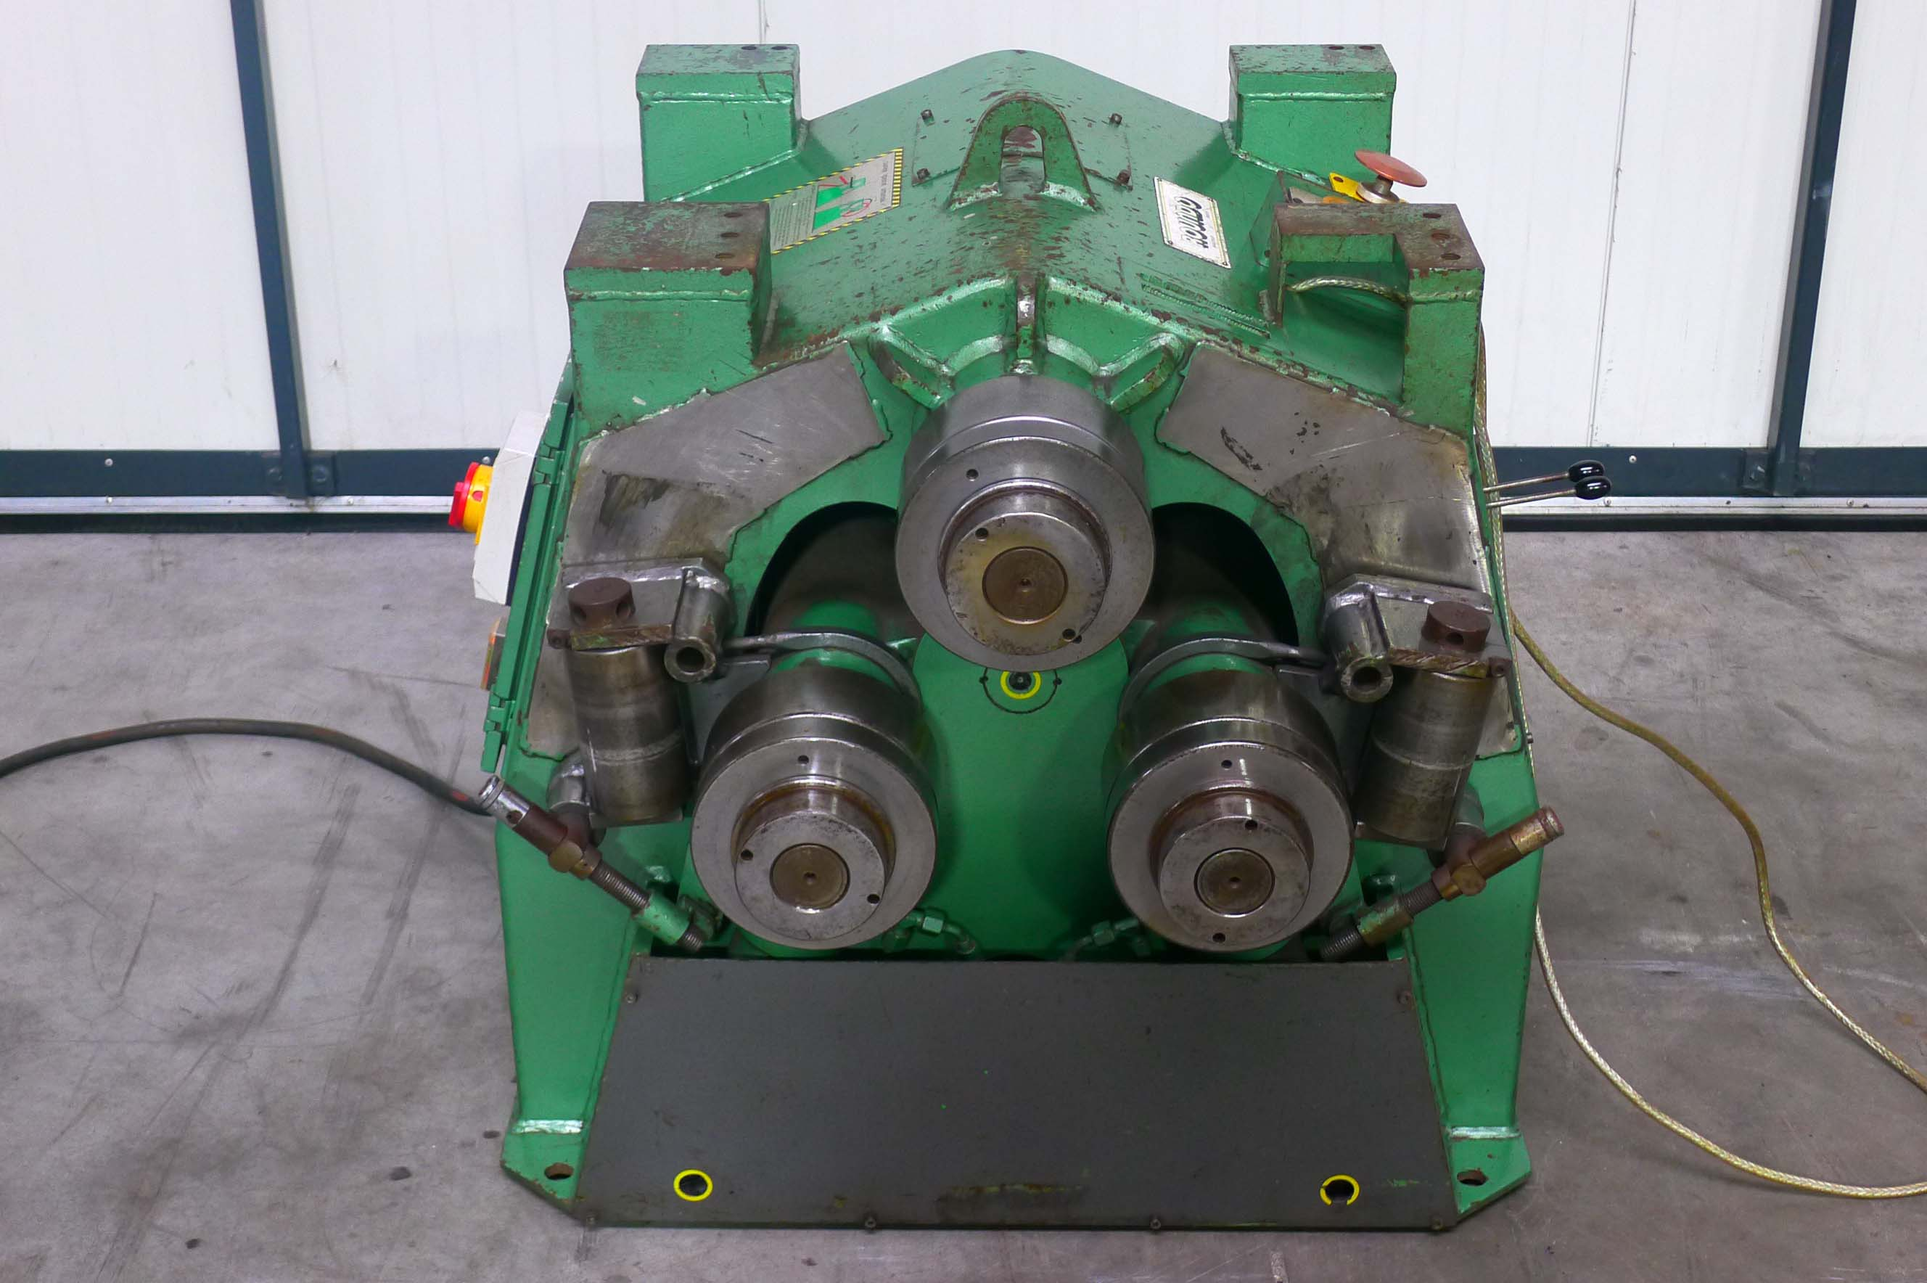

- Make : Roundo SWEDEN
- Typ : R 2
- Serial No. : 95 3581
- Age : 1995

- Ø shaft upper : 65 mm
- Ø shaft lower : 65 mm
- Ø rolls : 188 mm
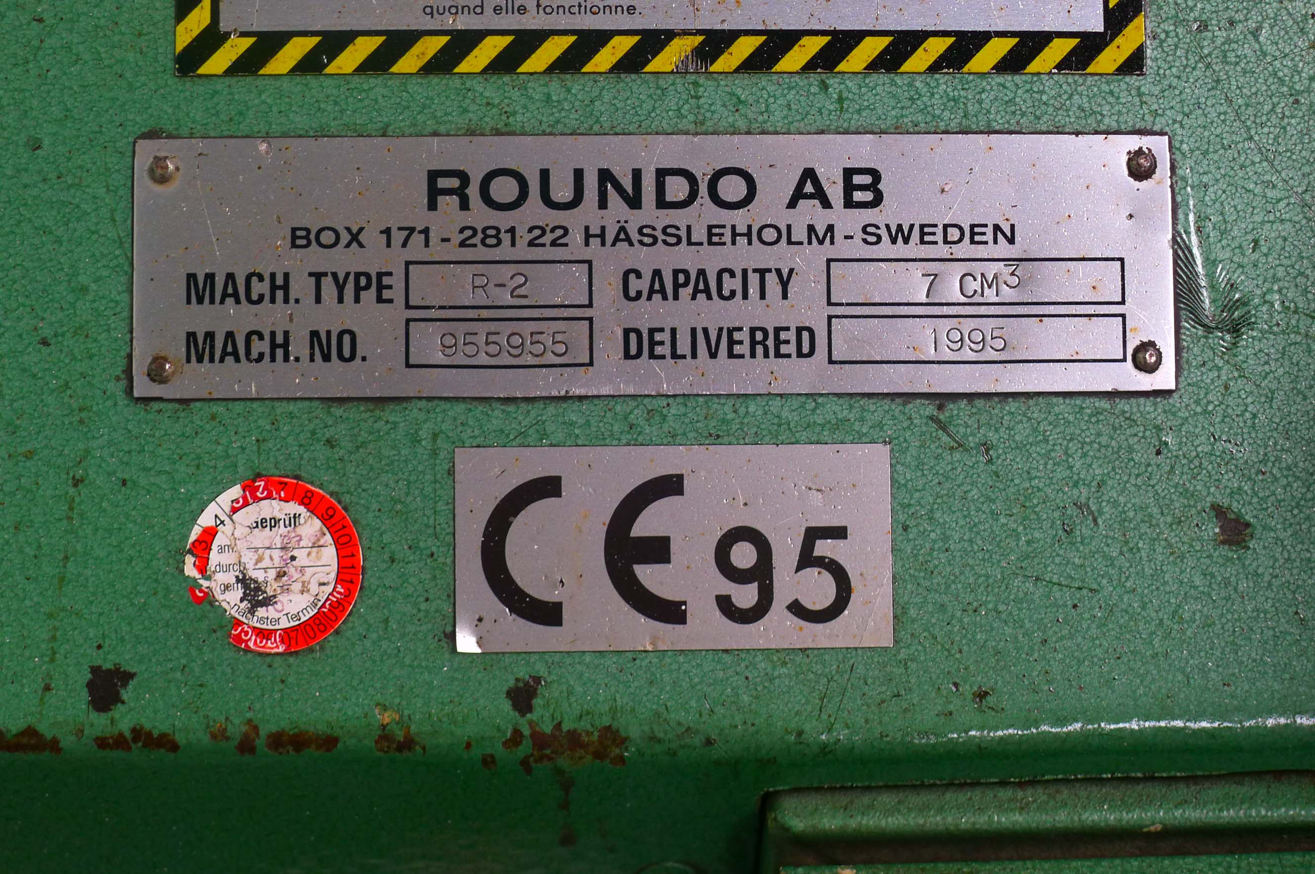

- Max. section bending : 7 cm³
- Bending speed : 0 - 5 m/min.
- Power : 2.2 kW
- Dimensions

- Capaciteit.
- Angle 60 x 60 x 6 : Ø 600
- T 60 x 60 x 7 : Ø 600
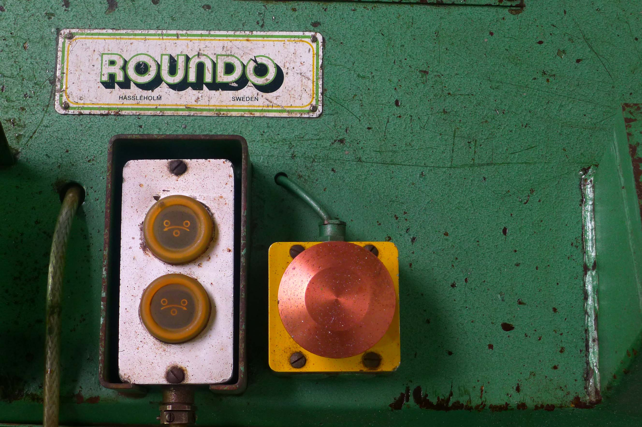
- Square 35 x 35 : Ø 450
- I IPE 100 : Ø 500

- Optical read out system for lower rolls.
- Remote control
- Three roll drive
- Guide rolls for Asymetric section bending
- Universal rolls for flat bar, angle & T section
and square bar.

- Very little used !

Please Note: The above information has been obtained to the best of our ability and belief from, and from the manufacturers where possible. It is given in good faith, but its accuracy can not be guaranteed. Accordingly, it will not form a representation or constitute contractual terms. We advise you to check any vital details!

